# Lab-10 WAP to study Using dynamic database in prolog.

Procedure:-

• Store facts of student(name, branch, semester , percentage) dynamically.

• Use asserta predicate to enter new data in dynamic database.

• Use retract predicate to delete a given data from dynamic db.

• Create appropriate predicate to search and display some specified students details.

• Create appropriate predicate to list all the students having percentage greater than some specified value

**Code:**

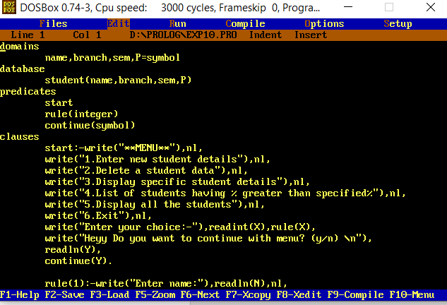

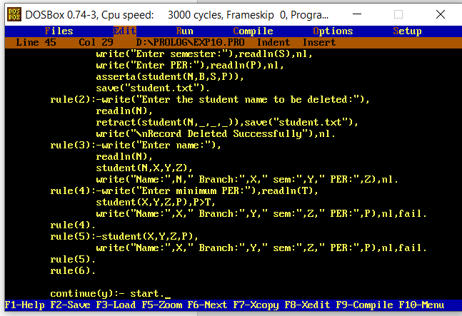

**domains**

**name,branch,sem,P=symbol**

**database**

**student(name,branch,sem,P)**

**predicates**

**start**

**rule(integer)**

**continue(symbol)**

**clauses**

**start:-write("**MENU**"),nl,**

**write("1.Enter new student details"),nl,**

**write("2.Delete a student data"),nl,**

**write("3.Display specific student details"),nl,**

**write("4.List of students having % greater than specified%"),nl,**

**write("5.Display all the students"),nl,**

**write("6.Exit"),nl,**

**write("Enter your choice:-"),readint(X),rule(X),**

**write("Heyy Do you want to continue with menu? (y/n) \n"),**

**readln(Y),**

**continue(Y).**

**rule(1):-write("Enter name:"),readln(N),nl,**

**write("Enter branch:"),readln(B),nl,**

**write("Enter semester:"),readln(S),nl,**

**write("Enter PER:"),readln(P),nl,**

**asserta(student(N,B,S,P)),**

**save("student.txt").**

**rule(2):-write("Enter the student name to be deleted:"),**

**readln(N),**

**retract(student(N,_,_,_)),save(“student.txt”),**

**write("\nRecord Deleted Successfully"),nl.**

**rule(3):-write("Enter name:"),**

**readln(N),**

**student(N,X,Y,Z),**

**write("Name:",N," Branch:",X," sem:",Y," PER:",Z),nl.**

**rule(4):-write("Enter minimum PER:"),readln(T),**

**student(X,Y,Z,P),P>T,**

**write("Name:",X," Branch:",Y," sem:",Z," PER:",P),nl,fail.**

**rule(4).**

**rule(5):-student(X,Y,Z,P),**

**write("Name:",X," Branch:",Y," sem:",Z," PER:",P),nl,fail.**

**rule(5).**

**rule(6).**

**continue(y):- start.**

**Output:**



